“LexVault - Legal Document Repository”

A Project Report Submitted in the partial fulfillment of the requirements for the award of the degree of

BACHELOR OF TECHNOLOGY

in

DEPARTMENT OF COMPUTER SCIENCE ENGINEERING

by

Bhavagna Reddy :2520030062

Vedika Kulkarni :2520030350

Tanvi Reddy :2520030548

Under the Guidance of

Dr. V.Sireesha
Professor
Department of Computer Science and Engineering





2026-27

DEPARTMENT OF COMPUTER SCIENCE ENGINEERING

Declaration

The Project Report entitled “LexVault - Legal Document Repository” is a record of Bonafide work of BHAVAGNA REDDY – 2520030062, VEDIKA KULKARNI – 25200300350, TANVI REDDY – 2520030548 submitted in partial fulfillment for the award of B. Tech in Computer Science and Engineering. The results embodied in this report have not been copied from any other departments/University/Institute.

BHAVAGNA REDDY – 2520030062
VEDIKA KULKARNI – 2520030350
TANVI REDDY – 2520030548

DEPARTMENT OF COMPUTER SCIENCE ENGINEERING

CERTIFICATE

This is certify that the mini project based report entitled “LexVault - Legal Document Repository” is a bonafide work done and submitted by BHAVAGNA REDDY – 2520030062, VEDIKA KULKARNI – 2520030350, TANVI REDDY – 2520030548 in partial fulfillment of the requirements for the award of the degree of BACHELOR OF TECHNOLOGY in Department of Computer Science Engineering, during the academic year 2026-27.

Signature of the Guide Signature of the HOD
(Dr. V.Sireesha)
ACKNOWLEDGEMENT

Description in Times New Roman font 12 size with two to three paragraphs thanking guide Dr. V.Sireesha , Professor, Dept. of CSE and Dr. P. Venkateswara Rao, Associate Professor, HOD CSE

BHAVAGNA REDDY – 2520030062
VEDIKA KULKARNI – 2520030350
TANVI REDDY – 2520030548

Abstract

LexVault is a legal document repository developed to demonstrate the practical application of Data Structures and Algorithms in the efficient searching, processing, and comparison of legal documents. The system provides a centralized platform for storing legal documents and allows users to search and analyze their contents using different string processing techniques.

The project implements several important algorithms to perform efficient text-based operations. The Knuth-Morris-Pratt (KMP) algorithm is used for exact pattern matching, enabling users to locate specific words or phrases efficiently. The Aho-Corasick algorithm is used for searching multiple keywords simultaneously, which is useful for identifying important legal clauses or terms within documents. Levenshtein Distance using Dynamic Programming is implemented for fuzzy matching, allowing the system to identify terms that are similar even when they are not exactly the same.

LexVault also incorporates Suffix Array and Longest Common Prefix (LCP) techniques for efficient text processing and document comparison. These techniques help identify common portions of text and analyze similarities between legal documents. The system therefore demonstrates how different data structures and algorithms can be applied to practical problems involving large amounts of textual information.

Overall, LexVault provides an application-oriented implementation of DSA concepts in the legal domain. The project combines document management, exact and fuzzy searching, keyword detection, and document similarity analysis into a single system. It demonstrates the importance of algorithm selection and efficient text processing in developing reliable and effective document retrieval and analysis applications.

Table of Contents

 |  |  | Page No.
 | Acknowledgement
 | Abstract
 | Table of Contents
 | List of Figures
1 | Introduction | 1.1 Overview  1.2 Problem statement  1.3 Scope of the project  1.4 Objectives | 8-11
2 | System Requirements | 2.1 Functional Requirements  2.2 Non-Functional Requirements | 12-14
3 | System Design | 3.1 High-level Architecture Diagram  3.2 Description of each layer | 15-18
4 | Implementation | 4.1 Module-wise implementation  4.2 Front-end logic (UI rendering, state management)  4.3 API integration  4.4 ……. | 19-25
5 | Results |  | 26-27
6 | Challenges & Limitations | 6.1 Issues faced during development  6.2 Solutions applied  6.3 Limitations of the System | 28-33
7 | Conclusion & Future Work | 7.1 Conclusion  7.2 Future Work  7.3 Skills learned during development | 34-38
 | References | - Books, tutorials, APIs, documentation sites used | 38-39

List of Figures

1.1 Overall Architecture of LexVault ........................................ 3
1.2 Workflow of the LexVault System ......................................... 5
1.3 Document Repository and Management Module ........................ 8
1.4 KMP-Based Exact Search Module ........................................... 10
1.5 Aho-Corasick Multi-Keyword Search Module ............................ 12
1.6 Levenshtein Distance-Based Fuzzy Search ............................... 14
1.7 Document Comparison Module .............................................. 16
1.8 Suffix Array and LCP-Based Text Analysis ............................... 18
1.9 Document Similarity Analysis ................................................ 20
1.10 Algorithm Lab Module .......................................................... 22
1.11 Sample Search Results ........................................................... 24
1.12 Document Comparison Results .............................................. 26

1.INTRODUCTION

1.1 Overview
Description of the project …..In Fig. 1.1 …..

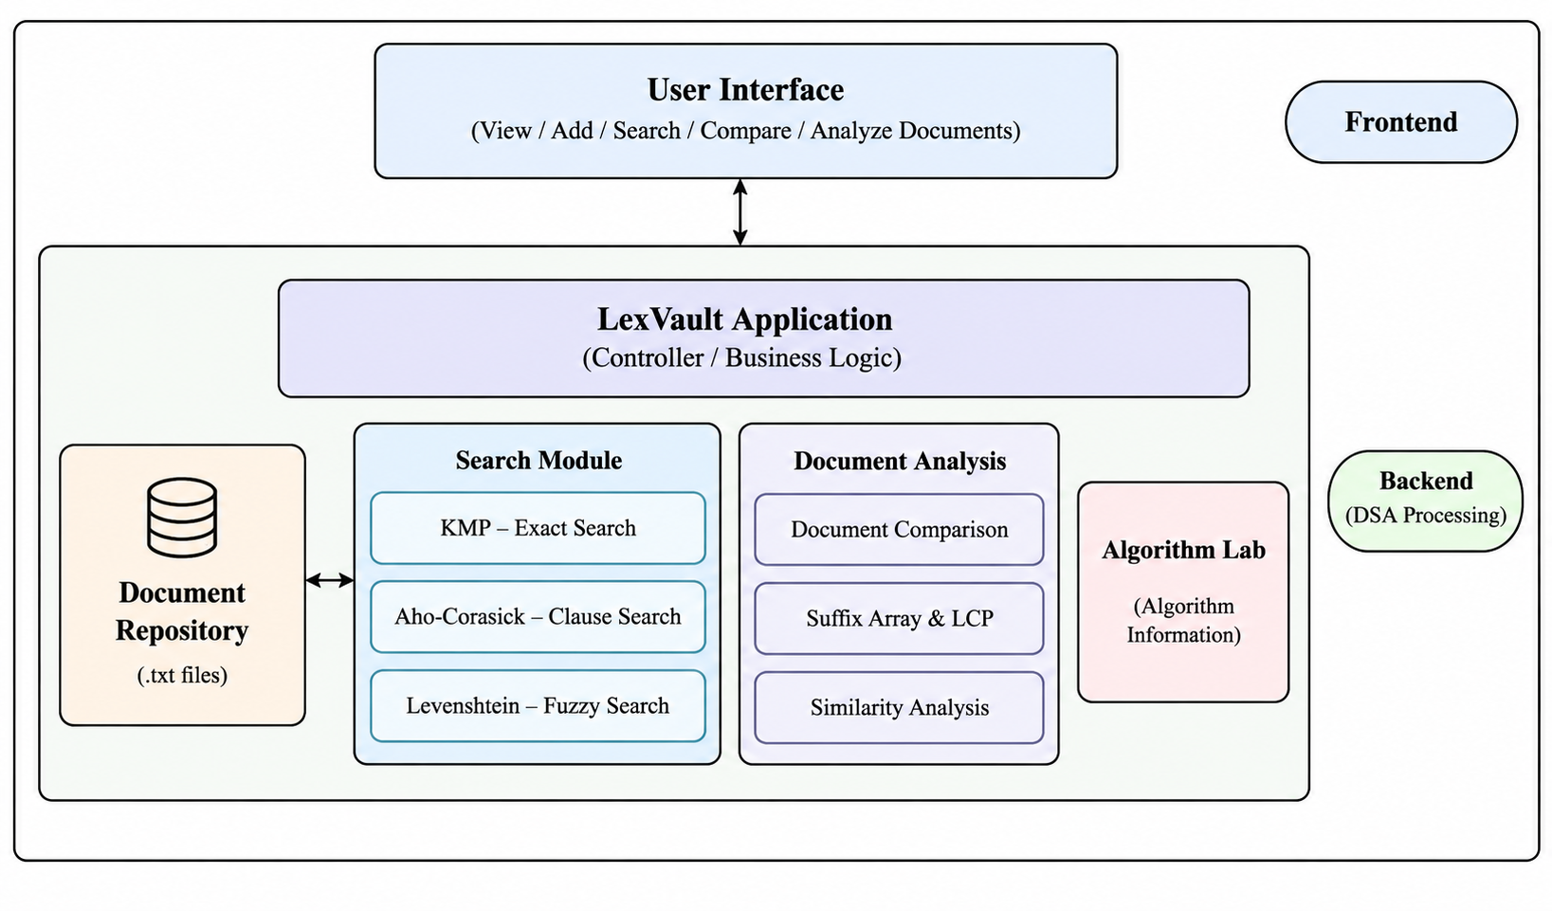
Fig. 1.1 LexVault Architecture
1.2 Problem Statement
Legal documents contain a large volume of textual information, including clauses, terms, conditions, and other important details. Searching and analyzing such documents manually can be time-consuming, especially when users need to locate specific phrases, identify multiple legal clauses, or compare the contents of different documents. Traditional sequential searching methods may also become inefficient when the amount of text increases.
Another important challenge is that users may not always remember the exact wording used in a legal document. Small spelling differences, word variations, or changes in phrasing can make exact searching ineffective. Similarly, identifying common clauses across multiple documents and determining how closely two legal documents are related requires efficient text-processing techniques.
The problem addressed by LexVault is to develop a legal document repository that applies appropriate Data Structures and Algorithms to improve the efficiency of document searching, processing, and comparison. The system provides a centralized environment where legal documents can be stored and accessed while supporting multiple types of text-based operations.
To address these requirements, LexVault implements different algorithms for different document-processing tasks. The Knuth-Morris-Pratt (KMP) algorithm is used for efficient exact phrase searching, while the Aho-Corasick algorithm supports simultaneous searching of multiple keywords or legal clauses. Levenshtein Distance using Dynamic Programming is used to identify similar text and support fuzzy searching when the searched term is not an exact match. The system also uses Suffix Array and Longest Common Prefix (LCP) techniques for analyzing common portions of text and identifying similarities between documents.
Therefore, the main problem is to design and implement a system that combines these DSA techniques to provide efficient and useful legal document retrieval and analysis. LexVault aims to reduce the effort required to search through legal documents while demonstrating how fundamental DSA concepts can be applied to a practical real-world text-processing application.

1.3 Scope Of The Project
The scope of LexVault is to develop a legal document repository that demonstrates the use of Data Structures and Algorithms for efficient text searching, document processing, and document comparison. The system focuses on providing users with a structured environment to store, access, search, and analyze legal documents.
The project covers exact and fuzzy text searching within legal documents. Exact phrase searching is supported using the Knuth-Morris-Pratt (KMP) algorithm, while fuzzy searching uses Levenshtein Distance with Dynamic Programming to identify terms that are similar even when there are minor differences in spelling or wording. The system also supports searching for multiple legal clauses or keywords using the Aho-Corasick algorithm.
Another important area within the scope of LexVault is document analysis and comparison. The system can compare legal documents and identify similarities in their textual content. Suffix Array and Longest Common Prefix (LCP) techniques are used for efficient text analysis and identification of common portions between documents. These features help demonstrate how different algorithms can be selected and applied according to the requirements of a particular text-processing operation.
The project also includes an Algorithm Lab that provides information about the algorithms implemented in the system. This makes the application useful not only as a document repository but also as a practical demonstration of DSA concepts and their real-world applications.
The scope of the project is primarily focused on document storage, text retrieval, pattern matching, fuzzy matching, clause detection, and document similarity analysis. It does not aim to replace professional legal software or provide legal advice. The system is developed as an academic project to demonstrate the practical implementation and performance of DSA techniques in the legal document domain.
1.4 Objectives

The main objective of LexVault is to develop an efficient legal document repository that demonstrates the practical application of Data Structures and Algorithms in searching, processing, and comparing textual information. The specific objectives of the project are:
- To develop a centralized legal document repository for storing and accessing legal documents in an organized manner.
- To implement efficient exact pattern searching using the Knuth-Morris-Pratt (KMP) algorithm for locating specific words and phrases within documents.
- To implement multi-pattern searching using the Aho-Corasick algorithm to identify multiple legal keywords or clauses efficiently.
- To provide fuzzy searching capabilities using Levenshtein Distance and Dynamic Programming to handle minor differences in words or phrases.
- To implement document comparison and similarity analysis for identifying common textual content between legal documents.
- To apply Suffix Array and Longest Common Prefix (LCP) techniques for efficient text processing and identification of common portions of documents.
- To provide an Algorithm Lab that helps demonstrate and understand the different DSA techniques implemented in the project.
- To demonstrate the practical application of DSA concepts in solving real-world text-processing and information-retrieval problems in the legal domain.

2.SYSTEM REQUIREMENTS

2.1 Functional Requirements

The functional requirements of LexVault define the operations and features that the system must provide to users. The system is designed to support legal document management, searching, text analysis, and document comparison using different Data Structures and Algorithms.
- Document Management
The system shall allow users to add, store, view, and access legal documents in the repository. Documents should be organized so that they can be easily retrieved for further processing.
- Document Viewing
The system shall allow users to select and view the contents of available legal documents before performing search or analysis operations.
- Exact Phrase Search
The system shall allow users to search for an exact word or phrase within a legal document. The KMP algorithm shall be used to perform efficient exact pattern matching.
- Fuzzy Search
The system shall support searches where the entered term may not exactly match the text in the document. Levenshtein Distance using Dynamic Programming shall be used to determine the similarity between terms.
- Multiple Keyword and Clause Search
The system shall allow users to search for multiple keywords or legal clauses at the same time. The Aho-Corasick algorithm shall be used for efficient multi-pattern matching.
- Document Comparison
The system shall provide a facility to compare two legal documents and identify common or similar textual content between them.
- Similarity Detection
The system shall analyze documents to determine the presence of similar text. Suffix Array and LCP-based processing shall be used to identify common portions of documents.
- Algorithm Information
The system shall provide information about the algorithms used in LexVault, including their purpose and application within the system.
- Search Result Display
The system shall display relevant search results clearly so that users can identify the matching terms, phrases, or clauses within the selected documents.
- User-Friendly Interaction
The system shall provide a simple interface through which users can select documents and perform the required searching and analysis operations without directly interacting with the underlying algorithms.

2.2 Non-Functional Requirements
The non-functional requirements of LexVault define the quality, performance, usability, and reliability expected from the system. These requirements describe how effectively the system should perform its functions rather than specifying individual features.
- Performance
The system should perform document searching and text-processing operations efficiently. The implemented algorithms should provide faster processing compared to basic sequential searching, especially when working with larger documents.
- Usability
LexVault should provide a simple and user-friendly interface. Users should be able to select documents, enter search terms, and perform document analysis without requiring detailed knowledge of the underlying algorithms.
- Efficiency
The system should use appropriate Data Structures and Algorithms for different operations. KMP, Aho-Corasick, Levenshtein Distance, Suffix Array, and LCP should be applied according to the requirements of each text-processing task.

- Reliability
The system should produce consistent and accurate search and comparison results for the same input. Document-processing operations should function correctly without unexpected failures during normal usage.
- Maintainability
The system should have a modular structure so that individual algorithms and components can be modified, tested, or improved without affecting the entire application.
- Scalability
The system should be capable of handling an increasing number of legal documents and larger amounts of textual data while maintaining reasonable processing performance.
- Accuracy
Search and document-analysis operations should provide relevant results based on the input provided by the user. Exact searches should identify matching phrases, while fuzzy and similarity-based operations should identify relevant similar text.
- Portability
The application should be capable of running on systems that support the required Java environment without depending on a specific computer or hardware configuration.
- Security
The system should provide appropriate protection for the stored legal documents and prevent unintended modification or access during normal operation.
- Extensibility
The system should allow additional algorithms or document-processing features to be incorporated in the future without requiring a complete redesign of the application.

- SYSTEM DESIGN
3.1 High-level Architecture Diagram

The high-level architecture of LexVault represents the major components of the system and how they interact with each other. The system is organized into different modules for document management, searching, and document analysis. The user interacts with the application through the user interface, while the backend processes the requested operations using appropriate Data Structures and Algorithms.

The main components of the LexVault architecture are:
- User Interface – Provides an interface through which users can select documents and perform different operations.
- LexVault Application – Acts as the main processing layer and manages user requests.
- Document Repository – Stores and provides access to the legal documents used by the system.
- Search Modules – Perform different types of text searching using KMP, Aho-Corasick, and Levenshtein Distance.
- Document Analysis Modules – Perform document comparison, similarity analysis, and common-text identification using appropriate algorithms.
- Algorithm Lab – Provides information about the algorithms used in the system.
- DSA Processing Layer – Performs the required algorithmic operations and returns the results to the application.
  - The overall architecture of LexVault is shown in Fig. 3.1.

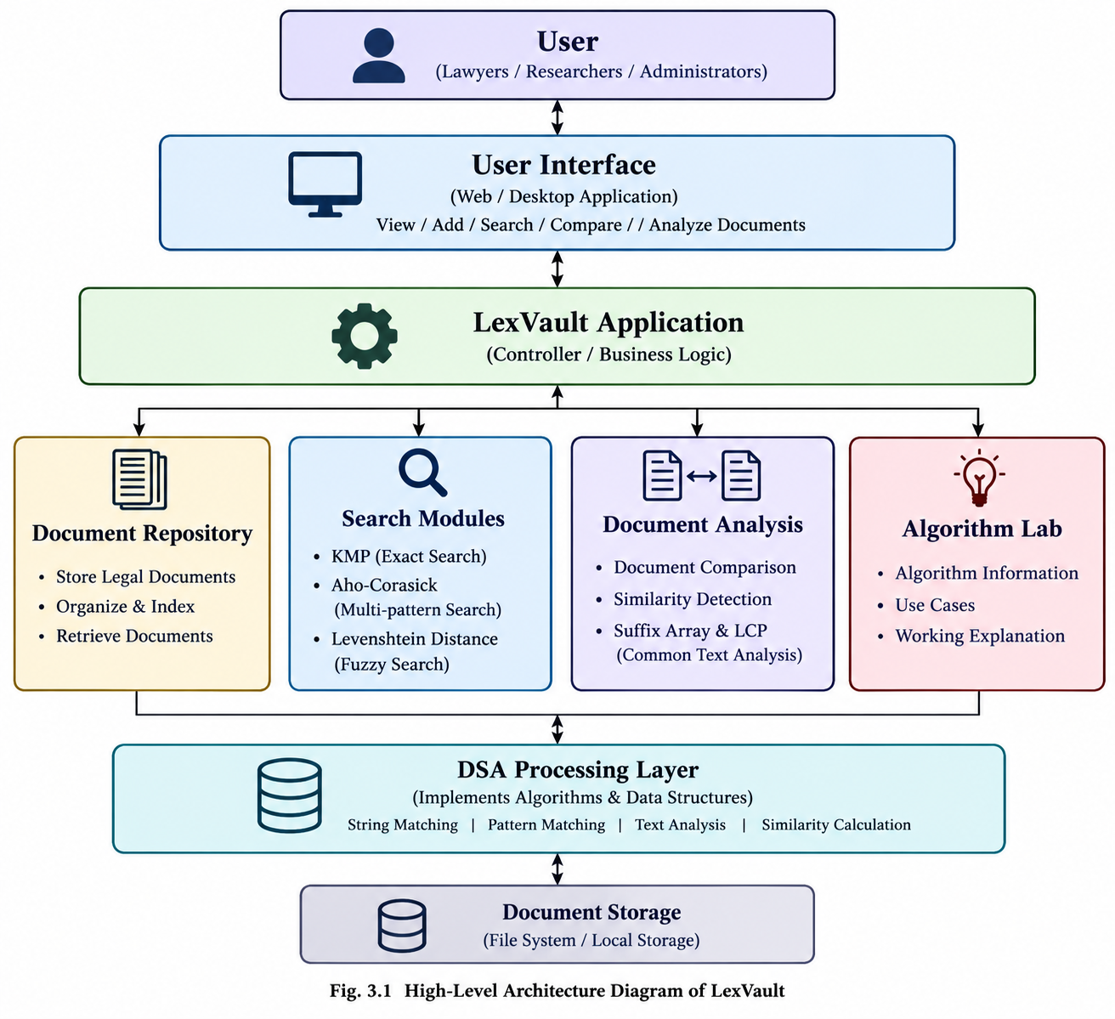

3.2 Description of each layer

The LexVault system is organized into multiple layers, where each layer has a specific role and responsibility. These layers work together to provide a structured system for storing, searching, analyzing, and comparing legal documents using Data Structures and Algorithms.
1. User Layer
The User Layer represents the people who interact with the LexVault system. Users access the system to perform operations such as viewing documents, searching for specific information, comparing documents, and analyzing legal text.
2. User Interface Layer
The User Interface Layer provides the interaction between the user and the LexVault application. It allows users to select documents, enter search terms, perform different operations, and view the generated results in an organized manner.
3. LexVault Application Layer
The LexVault Application Layer acts as the main processing and coordination layer of the system. It receives requests from the user interface and directs them to the appropriate module. It manages communication between the document repository, search modules, document analysis modules, and DSA processing components.
4. Functional Modules Layer
This layer contains the major functional components of LexVault.
- Document Repository: Manages the available legal documents and provides access to them.
- Search Modules: Perform different types of searches using algorithms such as KMP for exact searching, Aho-Corasick for multiple-pattern searching, and Levenshtein Distance for fuzzy searching.
- Document Analysis: Supports document comparison and similarity analysis using techniques such as Suffix Array and LCP.
- Algorithm Lab: Provides information about the algorithms used in the system and their applications.
5. DSA Processing Layer
The DSA Processing Layer is responsible for performing the actual algorithmic operations required by the system. It applies appropriate Data Structures and Algorithms to process legal documents and search queries. The algorithms include KMP, Aho-Corasick, Levenshtein Distance, Suffix Array, and LCP. The processed results are then returned to the application layer.
6. Document Storage Layer
The Document Storage Layer is responsible for storing the legal documents and related information used by LexVault. It provides persistent access to the documents so that they can be retrieved whenever required by the application and its processing modules.
Overall, these layers provide a structured architecture for LexVault and help separate user interaction, application processing, algorithmic operations, and document storage.

4.IMPLEMENTATION
4.1 Module-wise implementation
The system is organized into six major modules covering advanced algorithms in string processing, dynamic programming, network flow, NP-completeness, approximation, randomized algorithms, and parallel algorithms. Each module introduces a specific class of problems and demonstrates the algorithms used to solve them.
Module 1: TextHack as a System — The Advanced-Algorithm Question Bank
Module 1 introduces TextHack as a working text-analytics engine. Students can issue queries against an Indian-language Wikipedia corpus and observe the results before studying the internal implementation of the algorithms.
The system supports different query classes, including:
- Pattern Search – searching for a specific pattern within text.
- Fuzzy Matching – matching similar strings using edit distance.
- Document Similarity – identifying similarities between documents.
- Citation-Flow Analysis – analyzing relationships and flows between citations.
- Project-Scheduling Demonstrations – demonstrating scheduling problems and approximation approaches.
- Large-Prime Primality Testing – testing whether large numbers are prime using randomized algorithms.

Query Class | Algorithm Family
Pattern Search | String Algorithms
Fuzzy Matching | Dynamic Programming
Document Similarity | Suffix Structures
Citation Flow | Network Flow
Project Scheduling | NP-Hard Problems and Approximation
Primality Testing | Randomized Algorithms
Each query class is mapped to an appropriate advanced-algorithm family:

Module 2: String Algorithms
Module 2 focuses on algorithms for efficient processing and searching of strings. It begins with the basic string-matching problem of finding pattern P inside text T and examines the limitations of the naïve O(nm) approach.
The module implements and studies:
- Knuth-Morris-Pratt (KMP) – uses a failure function to achieve linear-time pattern matching.
- Z-Function – computes Z-values in linear time as an alternative approach to KMP.
- Rabin-Karp – uses polynomial rolling hashes for average-case linear-time searching.
- Aho-Corasick – supports multi-pattern matching using a trie with failure links.
- Suffix Arrays – provide a structure for organizing all suffixes of a text.
- LCP Array – uses the Kasai algorithm to calculate Longest Common Prefix values.
- Suffix Automata and Suffix Trees – introduced at preview level to understand their additional capabilities.
The module emphasizes both the algorithms and their asymptotic complexity.
Module 3: Advanced Dynamic Programming
Module 3 extends the Dynamic Programming concepts studied in DSA-2. It focuses on problems containing overlapping subproblems and optimal substructure.
The module covers:
- Edit Distance – including Levenshtein, Damerau-Levenshtein, and weighted edit distance.
- Wagner-Fischer Algorithm – used for computing edit distance.
- Sequence Alignment – Needleman-Wunsch for global alignment and Smith-Waterman for local alignment.
- Interval DP – including matrix-chain multiplication and optimal binary search trees.
- Bitmask DP – applied to problems such as Travelling Salesman and Hamiltonian path detection.
- DP on Trees – includes tree-based subset problems, diameter, centroid problems, and rerooting.
- SOS DP – Sum-over-Subsets Dynamic Programming for inclusion-exclusion and related problems.
The module also explains situations where Dynamic Programming is not an appropriate solution, such as problems where greedy methods are sufficient or where the state space becomes impractical.
Module 4: Network Flow
Module 4 introduces the maximum-flow problem, where a network contains a source, sink, capacities, and flow-conservation constraints.
The module covers:
- Ford-Fulkerson Method – finds augmenting paths in a residual graph.
- Max-Flow Min-Cut Theorem – establishes the relationship between maximum flow and minimum cut.
- Edmonds-Karp Algorithm – uses BFS to find augmenting paths and provides an O(VE²) implementation.
- Dinic's Algorithm – uses level graphs and blocking flows.
- Minimum Cut – used for partitioning problems.
- Bipartite Matching – demonstrates the application of maximum flow to matching and assignment problems.
- Min-Cost Max-Flow – introduced at the intuition level for optimal-cost assignment problems.
The module also discusses practical reductions of real-world problems to network flow, including image segmentation, project selection, and scheduling with deadlines.
Module 5: NP-Completeness and Approximation
Module 5 introduces computationally difficult problems and the concepts required to understand their complexity. It distinguishes between decision problems and optimization problems and introduces polynomial-time reductions.
The module covers:
- P, NP, and co-NP
- NP-Completeness
- Cook-Levin Theorem at an intuitive level
- SAT as the canonical NP-complete problem
- Reductions such as:
  - 3-SAT → CLIQUE
  - CLIQUE → INDEPENDENT-SET
  - INDEPENDENT-SET → VERTEX-COVER
  - SUBSET-SUM and KNAPSACK
  - HAM-CYCLE → TSP
- Recognition of common NP-hard structures
- Approximation Algorithms
- Vertex-Cover 2-Approximation using maximal matching
- PTAS, FPTAS, and APX
- Parameterized Complexity, including FPT and kernelisation
The module demonstrates why exact polynomial-time solutions are not known for many important computational problems and how approximation can provide practical solutions.
Module 6: Randomised and Parallel Algorithms
Module 6 introduces algorithms that use randomness and parallel computation to improve efficiency or solve large-scale problems.
The randomized-algorithm section covers:
- Las Vegas Algorithms – always produce correct results but may have variable running time.
- Monte Carlo Algorithms – provide results with a probability of correctness.
- Randomized Quicksort – analyzed using expected running time.
- Miller-Rabin Primality Test – used for probabilistic primality testing.
- Randomized Hashing – including universal hash families and perfect hashing.
- Reservoir Sampling – used for uniform sampling from streaming data.

The parallel-algorithm section introduces:
- Work and Span using T1T_1 and T∞T_\infty
- Brent's Theorem
- Parallel Reduce
- Parallel Scan/Prefix-Sum
- Parallel Sorting
- Differences between data-parallel and task-parallel computation
- Embarrassingly parallel problems
The module concludes by examining where parallelism is effective and where it provides limited benefit.
Overall Implementation
Together, the six modules provide a progression from practical text analytics to advanced algorithmic techniques. TextHack acts as the common system through which different algorithm families can be demonstrated, while the individual modules focus on the implementation, analysis, and application of those algorithms.

4.2 Front-end logic (UI rendering, state management)

The provided TextHack module description does not specify a particular front-end framework or UI technology. Therefore, the front-end logic can be described in terms of the system interactions and states required to support the different query classes.
UI Rendering
The front-end provides an interface through which users can interact with the TextHack engine and submit different types of algorithmic queries. The interface is designed to allow users to select or enter the required input and view the corresponding results.
The main UI operations include:
- Query Selection – The user selects the required query type, such as pattern search, fuzzy matching, document similarity, citation-flow analysis, project scheduling, or primality testing.
- Input Handling – The interface accepts the data required for the selected query, such as a search pattern, text, documents, graph information, scheduling input, or a number to be tested for primality.
- Query Execution – The submitted input is passed to the appropriate TextHack functionality through its public API.
- Result Rendering – The result returned by the engine is displayed to the user in an understandable format.
- Algorithm Demonstration – The interface allows users to observe the output of different advanced-algorithm families without requiring them to understand the internal implementation initially.
State Management
The front-end maintains the current state of the user's interaction with the system. The state changes according to the selected query and the input provided.
The major states include:
- Initial State – The system is ready to accept a query.
- Query Selection State – The selected algorithmic problem determines the required input fields.
- Input State – User-provided values are temporarily maintained before execution.
- Processing State – The submitted query is sent to the TextHack engine for processing.
- Result State – The output returned by the engine is displayed.
- Error/Invalid Input State – Invalid or incomplete inputs can be reported to the user when applicable.
Thus, the front-end acts as the interaction layer between the user and the TextHack algorithm engine. It handles input collection, query selection, communication with the system's public API, and presentation of results, while the actual algorithmic processing is performed by the corresponding modules.

4.3 API integration

The TextHack system uses a public API layer to provide access to the different algorithmic operations implemented by the engine. The API acts as an interface between the user-facing part of the system and the underlying algorithm modules.
The API integration works through the following steps:
- Request Generation
The user selects a query type and provides the required input through the front end.
- API Request Handling
The selected query and its input are passed to the corresponding TextHack API operation.
- Algorithm Selection
Based on the query type, the API directs the request to the appropriate algorithm family, such as string algorithms, Dynamic Programming, suffix structures, network flow, approximation algorithms, or randomized algorithms.
- Algorithm Execution
The selected algorithm processes the supplied input and generates the required result.
- Response Generation
The processed result is returned through the API to the front-end layer.
- Result Display
The front end receives the response and renders the result for the user.
The API therefore provides a clear separation between the user interface and algorithm implementation, allowing the algorithms to be accessed through a defined public interface without exposing their internal implementation details.
Note: The provided module description specifically mentions “Reading TextHack's public API end-to-end before any implementation work,” but it does not provide the actual API endpoints, request/response formats, or framework. Therefore, those implementation-specific details should not be added to the documentation unless they are available in the TextHack source code.

5.RESULTS

The implementation of the TextHack system demonstrates the practical application of advanced Data Structures and Algorithms through different types of queries. The system provides a common environment where users can execute algorithmic operations and observe their results.
The major results obtained from the implemented modules are as follows:
Text Analytics Results
The TextHack engine provides a working text-analytics environment where queries can be issued against an Indian-language Wikipedia corpus. Users can observe the output of different query types before examining the internal algorithmic implementation.
String Algorithm Results
The string-processing module demonstrates efficient pattern searching and multi-pattern matching using algorithms such as KMP, Z-function, Rabin-Karp, and Aho-Corasick. Suffix arrays and LCP processing are also used for advanced text analysis and similarity-related operations.
Dynamic Programming Results
The Dynamic Programming module demonstrates solutions for problems such as edit distance, sequence alignment, interval DP, bitmask DP, tree DP, and SOS DP. These implementations show how overlapping subproblems and optimal substructure can be used to solve complex computational problems.
Network Flow Results
The network-flow module demonstrates maximum flow, minimum cut, and bipartite matching problems. Algorithms such as Ford-Fulkerson, Edmonds-Karp, and Dinic's algorithm provide practical implementations of flow-based problem solving.
NP-Completeness and Approximation Results
The system demonstrates how computationally difficult problems can be identified through polynomial-time reductions. Approximation techniques, including the 2-approximation algorithm for Vertex Cover, demonstrate how useful solutions can be obtained for problems where efficient exact solutions are not known.
Randomized and Parallel Algorithm Results
The final module demonstrates randomized techniques such as Miller-Rabin primality testing, randomized hashing, reservoir sampling, and randomized Quicksort. It also introduces parallel computation concepts including work, span, parallel reduction, scan, and sorting.
Overall Result
Overall, the project successfully provides a practical platform for demonstrating advanced algorithmic techniques across multiple problem domains. The results show how different algorithm families can be selected according to the characteristics of a problem, while also emphasizing their computational complexity and practical applications.

6.CHALLENGES & LIMITATIONS
6.1 Issues faced during development

During the development of the TextHack system, several challenges were associated with implementing advanced algorithms and integrating them into a common text-analytics engine. The project covers multiple algorithmic areas, each requiring different approaches to problem-solving, implementation, and performance analysis.
1. Implementation of Advanced Algorithms
Implementing algorithms such as KMP, Aho-Corasick, suffix arrays, and advanced Dynamic Programming techniques required a clear understanding of their logic, data structures, and computational complexity.
2. Efficient String Processing
Searching large text collections efficiently was a major technical challenge. Basic string matching can become time-consuming for large inputs, making it necessary to implement efficient algorithms for exact pattern matching, multiple-pattern searching, and text analysis.
3. Dynamic Programming Complexity
Algorithms such as edit distance, sequence alignment, and bitmask DP required careful identification of states, transition rules, and base cases. Incorrect state definitions or transitions could lead to inaccurate results.
4. Network Flow Implementation
Implementing maximum-flow algorithms required proper handling of residual graphs, capacities, augmenting paths, and flow conservation. Ensuring that the algorithms produced valid flow results was an important challenge.
5. Understanding NP-Complete Problems
Understanding polynomial-time reductions and the relationships between NP-hard and NP-complete problems required careful analysis. Designing approximation algorithms also involved balancing solution quality with computational efficiency.

6. Randomized Algorithm Analysis
Randomized algorithms introduced challenges related to probability, expected running time, and correctness guarantees. Understanding the difference between Las Vegas and Monte Carlo algorithms was important for analyzing their behavior.
7. API Integration
Connecting the different algorithm modules through a common public API required a clear understanding of how queries, inputs, and outputs should be handled. Maintaining consistency between the interface and the algorithmic engine was an important design consideration.
8. Performance and Complexity Analysis
The system covers algorithms with different time and space complexities. Evaluating their efficiency for different input sizes and understanding the trade-offs between alternative approaches required careful analysis.
9. Implementation Without Built-in Java Utilities
The project specification restricts the use of java.util.* inside the engine. This constraint increases the implementation effort because students must build the required data structures and algorithmic components themselves rather than relying on standard Java utilities.
Conclusion: These challenges highlight the importance of algorithmic understanding, careful implementation, complexity analysis, and modular design when developing a system that demonstrates advanced Data Structures and Algorithms.

6.2 Solutions applied

To address the challenges encountered during the development of the TextHack — The Advanced-Algorithm Question Bank, suitable solutions were planned based on the system’s modules, algorithmic requirements, and implementation constraints.
1. Modular Implementation
The system was organized into six modules: String Algorithms, Advanced Dynamic Programming, Network Flow, NP-Completeness and Approximation, Randomized Algorithms, and Parallel Algorithms. This modular approach helps separate complex concepts and makes implementation, testing, and debugging easier.
2. Selection of Efficient String-Matching Algorithms
Different string algorithms were considered according to the query requirements. KMP and the Z-function support efficient pattern matching, Rabin–Karp uses rolling hashes, and Aho–Corasick handles multiple patterns. Suffix arrays and LCP arrays support substring-related operations and text analysis.
3. Structured Dynamic Programming
Dynamic programming problems were divided into smaller subproblems with clearly defined states, transitions, and base cases. Algorithms such as Wagner–Fischer for edit distance and bitmask DP for subset-based problems help organize computations and avoid unnecessary repeated work.
4. Systematic Network Flow Implementation
Network flow problems were approached using capacity constraints, residual graphs, and augmenting paths. Ford–Fulkerson and Edmonds–Karp provide methods for calculating maximum flow, while Dinic’s algorithm demonstrates the use of level graphs and blocking flows. These concepts also support demonstrations of minimum cuts and bipartite matching.
5. Handling NP-Complete Problems
For computationally difficult problems, polynomial-time reductions were used to understand relationships between known NP-complete problems. Approximation algorithms, such as the 2-approximation algorithm for Vertex Cover, provide practical approaches when finding an exact optimal solution may be computationally expensive.
6. Appropriate Use of Randomized Algorithms
Randomized algorithms were studied according to their guarantees and expected performance. Randomized quicksort demonstrates expected-time analysis, while Miller–Rabin provides a probabilistic approach to primality testing. The distinction between Las Vegas and Monte Carlo algorithms helps explain their different correctness and performance guarantees.
7. Understanding Parallel Processing
Parallel algorithms were analyzed using work and span to understand potential performance improvements. Techniques such as parallel reduction, prefix-sum operations, and parallel sorting demonstrate how independent computations can be organized for concurrent execution.
8. API and Interface Organization
The system’s public API was treated as the connection between user queries and the corresponding algorithm modules. A structured flow of input collection, query processing, algorithm execution, and result presentation helps maintain separation between the interface and the algorithmic logic.
9. Avoiding Built-in Java Utilities
Since the project specification prohibits the use of java.util.* inside the algorithm engine, the implementation approach requires students to construct the necessary data structures and algorithms manually. This encourages a deeper understanding of their internal working and computational complexity.
10. Performance and Complexity Analysis
The algorithms were evaluated conceptually using time and space complexity. Comparing approaches such as naïve string matching with KMP, or different maximum-flow algorithms, helps identify suitable methods for different input sizes and problem requirements.
In conclusion, these solutions provide a structured approach to addressing the technical challenges of TextHack. Modular design, appropriate algorithm selection, manual implementation, and complexity analysis support the development of a clear and maintainable advanced-algorithm learning system.
6.3 Limitations of the System
Although TextHack — The Advanced-Algorithm Question Bank is designed to demonstrate advanced algorithms through text analytics and computational problem-solving, the system has certain limitations.
1. Computational Complexity
Some algorithms, particularly bitmask dynamic programming and exhaustive search methods, require significant computational time and memory as the input size increases. Therefore, their practical use may be limited to smaller problem instances.

2. Limited Corpus Size and Language Coverage
The system is described as using an Indian-language Wikipedia corpus for text analysis. The results may depend on the size, quality, and language coverage of the available corpus. A limited corpus may not represent all linguistic variations or text-processing requirements.
3. Algorithm-Specific Limitations
Different algorithms are suitable for different types of queries. For example, string-matching algorithms are designed for pattern searching, whereas dynamic programming and network flow algorithms solve different classes of problems. A single algorithm cannot efficiently solve every query type.
4. Limitations of Fuzzy Matching
Fuzzy matching based on edit distance can require considerable computation for long strings or large collections of documents. The basic edit-distance approach may also fail to capture the meaning or context of words because it primarily measures differences between character sequences.
5. Challenges with Large Inputs
Processing very large text collections, complex networks, or high-dimensional computational problems may increase execution time and memory requirements. Performance depends on the chosen algorithm, input characteristics, and available system resources.
6. Approximation of NP-Hard Problems
For NP-hard optimization problems, obtaining an exact optimal solution may be computationally expensive for large inputs. Approximation algorithms can provide practical solutions, but their results may not always be optimal.
7. Probabilistic Nature of Randomized Algorithms
Some randomized algorithms, such as Miller–Rabin primality testing, provide probabilistic guarantees rather than absolute certainty in every execution. Their reliability depends on the algorithm and its chosen parameters.

8. Limitations of Parallel Processing
Parallel algorithms may require additional resources and coordination. The actual speed improvement depends on the available hardware, the amount of parallelizable work, and communication overhead. Not every task benefits equally from parallel execution.
9. Implementation Constraints
The project specification prohibits the use of java.util.* inside the algorithm engine. Consequently, implementing data structures and supporting operations manually may increase development time and make debugging more challenging.
10. Dependence on the Available Interface and Integration
The system’s usability depends on how its public API, input handling, algorithm modules, and result presentation are integrated. The exact limitations of the interface and API cannot be determined without details of the completed implementation.
In conclusion, TextHack provides a framework for demonstrating advanced algorithmic concepts, but its performance and practical applicability depend on input size, algorithm selection, available resources, and implementation quality. These limitations can guide future improvements in optimization, corpus coverage, usability, and scalability.

7.CONCLUSION & FUTURE WORK
7.1 Conclusion
TextHack — The Advanced-Algorithm Question Bank is designed to provide a structured approach to understanding and demonstrating advanced algorithms through practical text analytics and computational problem-solving. The system connects theoretical algorithmic concepts with their potential applications in real-world problems.
The project covers six major areas: String Algorithms, Advanced Dynamic Programming, Network Flow, NP-Completeness and Approximation, Randomized Algorithms, and Parallel Algorithms. Each module focuses on different computational challenges, including efficient pattern matching, text similarity, optimization, network analysis, probabilistic computation, and parallel processing.
The project emphasizes understanding the internal working of algorithms, selecting appropriate approaches for different problem types, and analyzing their time and space complexity. The requirement to implement algorithms without relying on the prohibited java.util.* utilities within the algorithm engine also encourages a deeper understanding of data structures and algorithm design.
Furthermore, TextHack provides a framework for exploring how advanced algorithms can be applied to text processing, document analysis, scheduling, and other computational tasks. Its modular structure supports the organization of different algorithmic techniques within a common system.
In conclusion, TextHack represents an educational approach to advanced algorithm design and analysis. It aims to strengthen problem-solving abilities, improve understanding of computational efficiency, and demonstrate the relevance of advanced algorithms to practical applications. The system can be extended in the future through performance optimization, broader corpus support, and additional algorithmic capabilities.
7.2 Future Work
The TextHack — The Advanced-Algorithm Question Bank can be enhanced in several ways to improve its functionality, efficiency, and usability. The following improvements can be considered for future development.

1. Expansion of the Text Corpus
The system can be extended to support larger text collections and additional Indian languages. This would help demonstrate the performance of string algorithms and text-analysis techniques across different datasets.
2. Performance Optimization
The implementation of algorithms such as KMP, Aho–Corasick, suffix arrays, and network flow algorithms can be optimized to handle larger inputs efficiently. Further improvements in memory management and execution time could enhance overall performance.
3. Addition of More Advanced Algorithms
Future versions can incorporate additional algorithms and variations, including improved suffix-array construction techniques, advanced dynamic programming methods, and more efficient graph algorithms. This would broaden the range of computational problems supported by the system.
4. Improved User Interface
The user interface can be enhanced to make algorithm selection, query submission, and result visualization more intuitive. Interactive demonstrations could help users understand how an algorithm processes input step by step.
5. Visualization of Algorithm Execution
Visual representations of string matching, dynamic programming tables, residual networks, and parallel computation could be introduced. These visualizations would help students understand algorithm execution and the decisions made at different stages.
6. Enhanced Document Similarity Analysis
The system could be extended to support more advanced document comparison methods. Combining edit distance with additional text-analysis techniques could provide a broader understanding of document similarity beyond character-level differences.
7. Improved Scalability
The system could be designed to process larger datasets and more complex computational problems. Efficient indexing, memory optimization, and parallel execution may help improve scalability as the workload increases.
8. Testing and Benchmarking
Future development could include a comprehensive testing framework to evaluate correctness, execution time, and memory usage across different input sizes. Comparing multiple algorithms that solve similar problems would help demonstrate their practical trade-offs.
9. Enhanced Randomized and Parallel Computing
Additional randomized algorithms and parallel techniques could be incorporated to demonstrate probabilistic computation and performance improvements. Benchmarking sequential and parallel implementations would help evaluate the benefits and limitations of parallel execution.
10. Extended Educational Features
The system could include sample queries, explanations of algorithmic complexity, example inputs and outputs, and interactive learning exercises. These features would make TextHack more useful as an educational platform for students studying advanced algorithms.
In conclusion, future enhancements can transform TextHack into a more comprehensive and interactive learning system. Improvements in algorithm optimization, visualization, scalability, and testing could increase its educational value and demonstrate the practical relevance of advanced algorithms to real-world computational problems.
7.3 Skills learned during development
The development of LexVault – Legal Document Repository provided valuable learning experiences in Data Structures and Algorithms (DSA), problem-solving, and software development. The project helped us understand how theoretical concepts can be applied to practical applications involving legal document searching, processing, and comparison.
1. Understanding of Data Structures and Algorithms
We gained a deeper understanding of various algorithms, including Knuth-Morris-Pratt (KMP), Aho-Corasick, Levenshtein Distance, Suffix Arrays, and Longest Common Prefix (LCP). We learned how to select suitable algorithms based on the requirements of different text-processing operations.

2. String Processing and Pattern Matching
We learned how to perform exact pattern matching, search for multiple keywords simultaneously, and identify similar words or phrases. These techniques helped us understand how efficient searching can improve information retrieval from large text collections.
3. Dynamic Programming
The project improved our understanding of Dynamic Programming through the implementation of Levenshtein Distance. We learned how to divide a complex problem into smaller subproblems and use their results to calculate the final output efficiently.
4. Document Comparison and Similarity Analysis
We learned how to compare textual content and identify common portions of different documents. The use of Suffix Arrays and LCP techniques helped us understand the importance of efficient text analysis and similarity detection.
5. Algorithm Analysis and Optimization
We gained knowledge of time and space complexity and learned how different algorithms perform under different input conditions. This helped us understand the importance of selecting efficient solutions for handling large amounts of textual data.
6. Software Development and Modular Design
The project helped us understand the importance of organizing an application into separate functional modules, such as document management, search operations, document comparison, and the Algorithm Lab. Modular design makes a system easier to understand, maintain, test, and extend.
7. Problem-Solving and Debugging
During development, we improved our analytical thinking and debugging skills by understanding algorithmic logic, identifying implementation issues, and working toward reliable results. We also learned the importance of testing different inputs and handling edge cases.

8. Practical Application of DSA Concepts
Finally, the project helped us connect theoretical DSA concepts with a real-world application. We understood how efficient algorithms can reduce the effort required to search, retrieve, and analyze legal documents, demonstrating the practical importance of algorithm design in software development.
In conclusion, the development of LexVault strengthened our technical knowledge, logical reasoning, problem-solving abilities, and understanding of efficient software design. The experience provided a strong foundation for applying Data Structures and Algorithms to more complex software development projects in the future.

REFERENCES
[1] T. H. Cormen, C. E. Leiserson, R. L. Rivest, and C. Stein, Introduction to Algorithms, 4th ed. MIT Press, 2022.
[2] D. E. Knuth, J. H. Morris, and V. R. Pratt, “Fast Pattern Matching in Strings,” SIAM Journal on Computing, vol. 6, no. 2, pp. 323–350, 1977.
[3] A. V. Aho and M. J. Corasick, “Efficient String Matching: An Aid to Bibliographic Search,” Communications of the ACM, vol. 18, no. 6, pp. 333–340, 1975.
[4] V. I. Levenshtein, “Binary Codes Capable of Correcting Deletions, Insertions, and Reversals,” Soviet Physics Doklady, vol. 10, pp. 707–710, 1966.
[5] U. Manber and G. Myers, “Suffix Arrays: A New Method for On-Line String Searches,” SIAM Journal on Computing, vol. 22, no. 5, pp. 935–948, 1993.
[6] T. H. Cormen, C. E. Leiserson, R. L. Rivest, and C. Stein, Introduction to Algorithms, 3rd ed. MIT Press, 2009.
[7] Oracle, “Java Documentation.” Available: https://docs.oracle.com/en/java/
[8] GeeksforGeeks, “String Matching Algorithms.” Available: https://www.geeksforgeeks.org/
[9] CP-Algorithms, “String Processing.” Available: https://cp-algorithms.com/string/
[10] MIT OpenCourseWare, “Introduction to Algorithms.” Available: https://ocw.mit.edu/

